**Musubi Meeting (Solo Play) #AlteredFanContent**

Legal Stuff

Musubi Meeting is unofficial content created by Gavken, a fan of Altered. It is not endorsed by Equinox. Portions of this material are the property of Equinox.

Objective

You and your companion are racing to meet at the Musubi Meeting. You must get there in time without getting distracted too much to be able to complete the ceremony. The more you demonstrate your abilities as a Musubi the easier the Ceremony will be. This is a solo game which runs using a semi random event deck to script events that your hero and companion come across on their way to the ceremony.

Setup

Use two sets of standard region cards, shuffle them up and add two of these region cards randomly to either side of the central Spindle Card (Musubi Meeting), with only have the A card showing under the hero and companion start tiles. Add a Tumult token to any B region with a single biome as you go. This Tumult token will trigger an extra event at Noon when your expedition reaches it based on your faction in the dangerous B region.

‘A’ Events

Spindle

Hero start

Companion start

Shuffled region cards

Shuffled region cards

‘A’ Events

‘B’ Events

‘B’ Events

Normal Round Gameplay

You play your turn as you normally would in a game of Altered, except when you draw cards, you will also draw an event card that will simulate an event that affects your hero and the characters and landmarks you summon. If you must ever discard a card, you must choose the card with the highest total biome stats (for characters) or mana cost (for permanents / spells). Where there is a tie for this, shuffle them up and discard one of these at random. When your furthest expedition (hero or companion) is on the hero or companion start card or the closest region card to it, then draw from the A event deck. When the furthest expedition is on the region card closest to the Spindle or on the Spindle itself, draw the event from the B event deck.

The event cards will either have to exceed the enemy characters on the biomes where your hero and companion are located OR you need to gain a number of counters to advance. If the event deck has a token creature in play at dusk that creature’s stats will add to the biome difficulty that you must face. Sometimes an event will override a biome set for the hero / companion.

The event plays just like an opponent would in the afternoon but only will play its event actions for 3 rounds. If you have more than 3 rounds that you can play you can play cards beyond the third round until you pass.

You must get at least one advancement to succeed at an event. If you fail it, then keep that card in front of you for when you get to the Musubi ceremony. Those symbols will make the final ceremony much harder at the end of the game and the more you have the harder it will be to succeed. Generally enemy cards will go away at Night unless it specifically says so on the card.

Special Rules for the Scenario

No piece of text on a card in play can trigger more than three times. Thus, if you have a Haven, Bravos Bastion in play you can only gain from its effect on three characters entering play from reserve. This rule is designed to prevent powerful unique cards from getting infinite combos but also to balance things for the scenario. Where you feel something will fire a number of times mark the card with cubes to indicate how many times you have used the text.

If the scenario has the first player token, its first action will be AFTER YOU.

Musubi Ceremony

The special event to simulate the Musubi ceremony at the end of the game which occurs when both your hero and companion reach that space. Once either your hero or your companion reaches the centre, they will not advance any further and they remain there until your opposite number joins you.

When both expeditions are on the Spindle, do not draw an event, and instead the event is the Musubi Ceremony on the Spindle itself which will determine if you succeed or fail at the game. This event works like the tie breaker Arena where both expeditions count towards the target number you must exceed. The first thing you do in the ten is discard down to ten mana orbs in your mana phase instead of adding a new mana orb.

This event is mitigated by the number of failure tokens you have in front of you. At noon look for each of the symbols on cards you have failed and apply the result. Do this in order from top to bottom of the card.

First of all, find how many combat events you failed and then add a 3/3/3 druid token to opposition expeditions. Each one of these will go to the hero side first, then the next one to the companion side, then back to the hero side etc.

Discard one of your mana orbs for each event you have with this symbol. If you have three of these symbols, then you will need to discard three mana orbs.

Discard a card from your reserve or a permanent for each of this token you have on events that you failed. You may choose each time which of the two you want to do (and you must do one if you possibly can).

Discard a creature that you already have in play for each of these tokens that you have. This could be creatures that were anchored, eternal, asleep, or even token creatures generated in or before noon. If you cannot do this, then you instead put a 1/1/1 recruit into play and boost all enemy tokens (Charge). If you have to do this multiple times, then the charge will affect tokens multiple times and will also affect any 3/3/3 druids from the combat events.

You can then keep playing cards until you have no more to play OR run out of mana. Then compare the difficulty against the Musubi Meeting difficulty and if you exceed it on at least two of the three biomes then you succeed at the ceremony.

Scenario Difficulty

This can be chosen at the start of a game with a default being 12.

The Broken Lyra Caravan



The Lost Twins

The Strange Portal



The Great Mist

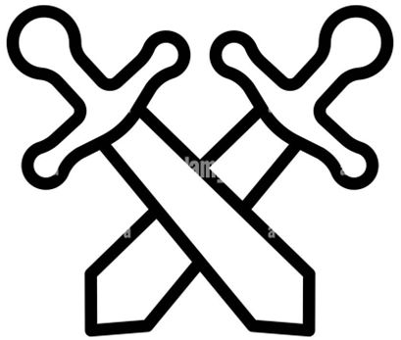

NOON

NOON

NOON

DUSK

AFTERNOON

AFTERNOON

AFTERNOON

Up ahead a Lyra Caravan is in trouble. Its axle is broken, and their possessions scattered all over the road.

A man up ahead is wailing in grief. He has lost his twin boys who are lost and is frightened that they may have been taken by the Tumult.

You must sacrifice a permanent to get parts to repair the caravan. If you do, gain a help token.

1. Remove a character from reserve to go and get help. Gain a help token.
2. Spot a boost in your expedition to lift caravan and gain a help token.
3. Spot a character with at least 4 in one biome stat to repair the caravan & gain 1 help token.

If you have 3 help tokens compare your stats to advance your hero. If 4 then advance both. Remove all help tokens.

1. After You
2. Put a spell into reserve to search for the twins. If you do not all characters gain fleeting.
3. Bring an x/x/x twin copy token into play in each expedition where x is the highest biome stat currently in play.
4. An angry Elk 2/2/2 token comes from the mist and attacks your hero.
5. An angry Stag 3/3/3 token comes from the mist and attacks your companion.
6. A mad Elk 4/4/4 token comes from the mist and attacks your hero. If you have no permanent one joins the companion side also

You are lost in a never-ending fog created by the Tumult. You must find your way back to the path.

Banish all token creatures.

Compare your biome scores against the mist creatures and equal or exceed the target scores to progress.

There is a strange magical portal in your way. You decide to investigate it.

AFTERNOON

DUSK

NOON

Discard a card from hand. If you cannot, move your companion expedition back 1

1. Spot a character with anchored or seasoned and gain a magic token.
2. Discard a creature to reserve with at least 2 in two biome stats to investigate it. Gain a magic token.
3. Cast a non-disruption spell. If the spell resolves, gain a magic token.

DUSK

If you have 2 tokens advance your companion. If you have 3 tokens advance both and swap their positions.

If you exceed the twins on an expedition then advance on that side. If you exceed both advance on both sides.

If you have 2 characters in reserve, discard the one costing most total mana.

DUSK

**B**

**B**

**B**

**B**

Mushrooms!

Harvest Time



Butterfly Trail



Expanding Terror



NOON

NOON

NOON

DUSK

AFTERNOON

AFTERNOON

AFTERNOON

Hungry after a long day’s walk you decide to eat some tasty mushrooms.

When going through a farmer’s field you find the farmer in a panic. The field must be harvested before a Tumult storm comes in and only you can help.

All characters in play gain asleep.

1. Add a 1/1/1 Mushroom token to the enemy hero and companion expedition.
2. Your character with highest stats gains asleep.
3. Add 1 boost to each mushroom in play for each biome in this region.

If you beat the biomes with a mushroom token in play your hero / companion expedition(s) advance.

1. Gain a help token if you can spot a creature.
2. Gain a help token if you can spot two creatures.
3. Gain a help token if you can spot three creatures.
4. Gain a help token if you sacrifice a plant.
5. Put a 3/3/3 Horror Token into play in both expeditions.
6. If you have more than four mana orbs, add 1 boost to all Horror Tokens.
7. If you have more than six mana orbs, add 1 boost to all Horror Tokens.

Ahead of you there is something quite hideous looking and it appears to be growing.

Send all creatures to reserve.

Compare your biome scores against the Horror tokens and exceed the target scores to progress on one or both sides.

You are amazed at a giant butterfly and decide to follow it. It leads you into a weird magic pulsing land.

AFTERNOON

DUSK

NOON

Sacrifice a gear. If you cannot, put a 2/2/2 moth token in the companion expedition.

1. Sacrifice a permanent.
2. Remove a fleeting token.
3. Switch your highest hand cost creature in your hero exp with the lowest in your companions exp. If you cannot then sacrifice a creature.

DUSK

Compare your biome scores against the target value of 3 plus the moth score and exceed them to advance.

Advance your companion expedition if you have 3 help tokens or both expeditions if you have 4 help tokens.

Put an extra card into mana from you hand

DUSK

**A**

**A**

**A**

**A**

Lover’s Tiff

Runaway Machine

Tear in the Tumult



The Clones



NOON

NOON

DUSK

AFTERNOON

AFTERNOON

AFTERNOON

You encounter a woman who is arguing with her partner about wanting similar things. You must show her that diversity can be a good thing.

Two experimental Axiom devices are out of control and heading for a woman’s home. You must stop them before they destroy the house.

Sacrifice a token character.

1. Gain a diversity token if you have a character with Anchored or Seasoned or Eternal.
2. Gain a diversity token if you have a character with Gigantic or Asleep or Fleeting.
3. Gain a diversity token if you have at least one boost on each expedition.

If you have 2 diversity tokens you may advance on one side. If you have three diversity tokens you may move both.

1. Spawn a 3/0/0 fire token in the hero expedition if there is 1 machine and in both if there are 2.
2. Spawn a 3/0/0 fire token in the companion expedition if there is 1 machine and in both if there are 2.
3. Spawn a 3/0/0 fire token in each expedition
4. Put an x/x/x clone token into hero exp where x is the number of mana orbs - 3.
5. Put an x/x/x clone token into comp exp where x is the number of mana orbs - 3.
6. Put an x/x/x clone token into both exp where x is the number of mana orbs - 3.

The vegetation ahead of you has an odd look to it. You are wary as you advance.

Discard all non-token characters from play.

Compare your biome scores against the clones on both sides. Each expedition advances if you beat or equal them.

Ahead you see a tear in the tumult. You must seal it before a nasty chimera comes through.

AFTERNOON

DUSK

NOON

Put an additional card from your hand into mana. Gain a Closure token

1. Discard a card from hand to reserve to begin casting and gain a Closure token
2. Sacrifice a creature to gain a closure token.
3. Cast a spell. Gain a closure token.

DUSK

If you have 3 closure tokens advance your companion expedition. If you have 4 then advance both.

Only the forest biome counts despite the region card. Defeat the remaining fire tokens to advance on either side.

Put two runaway machine permanent landmarks in play with tough 1.

DUSK

NOON



**B**

**B**

**B**

**B**

Meeting and Greeting

Precise Calculations

Magical Schooling



Hydra Attack!



NOON

NOON

NOON

DUSK

AFTERNOON

AFTERNOON

AFTERNOON

You encounter a village and must greet as many different eidolons there as you can.

An axiom engineer is trying to get her calculations correct for repairing a Aerocopter. You must measure up to help her.

If you can spot a non-token character, draw a card.

1. Spot a character to gain 1 greeting token.
2. Spot a character with none of the same types as any other characters in play to gain 1 greeting token.
3. Spot a character with none of the same types as any other characters in play to gain 1 greeting token.

If you have 3 greeting tokens you may move either you hero or companion expedition forwards.

1. Add a 1/1/1 boost to target character.
2. Add a 1/1/1 boost to target character.
3. Add a 1/1/1 boost to target character.
4. Put an x/x/x Hydra token in play in both expeditions where x is the no. of hydra tokens -1
5. Put an x/x/x Hydra token in play in both expeditions where x is the no. of hydra tokens -2
6. Put an x/x/x Hydra token in play in both expeditions where x is the no. of hydra tokens -3

Ahead of you there is something quite hideous looking and it appears to be growing.

Destroy target permanent (your choice).

Compare your biome scores against the Hydra tokens and exceed the target scores to progress on either side.

You encounter some Yzmir students and are asked to show them your skills.

AFTERNOON

DUSK

NOON

Discard a spell from your reserve. If you can’t, sacrifice a mana orb.

1. Spot a boosted character to gain a Magic token.
2. Spot an asleep character to gain a Magic token.
3. Spot another boosted character to gain a Magic token.
4. Spot a spell in your reserve to gain a Magic token.

DUSK

If you have 3 magic tokens advance your companion expedition. If you have 4 the advance both expeditions.

If you can spot the four of the numbers 2-6 on biome stats for amongst characters you control advance an expedition.

Gain the first player token even if you don’t have it and discard a card from reserve.

DUSK



**B**

**B**

**B**

**B**



The Bravos Explorer

The Boat Crossing

Honouring the Memories



The Battle Line



NOON

NOON

NOON

DUSK

AFTERNOON

AFTERNOON

AFTERNOON

You encounter an explorer keen to explore the lands. He invites you to join him if you can keep up.

The boatsman for the crossing has a leaky boat. You need to provide help for him to bail it as you cross the lake.

Send all characters in play to the reserve & gain the 1st player token.

1. Have 2 or more points of stats in a forest biome to gain an explorer token.
2. Have 3 or more points of stats in a mountain biome to gain an explorer token.
3. Have 4 or more points of stats in a water biome to gain an explorer token.
4. .

If you have 3 exploration tokens you may move either you hero or companion expedition forwards.

1. After you.
2. Add a -1/-1/-1 counter to target character.
3. Add a -2/-2/-2 counter to target character with at least 1 stat in the water biome.
4. Discard a 1/1/1 Ordis recruit unless one Ordis token has at least 1 boost.
5. Discard a 1/1/1 Ordis recruit unless a different token has at least 1 boost.
6. Discard a 1/1/1 Ordis recruit unless a different token has at least 1 boost.

You see a group of Ordis soldiers hard pressed against a fearsome Chimera. You go to help them.

Put three 1/1/1 Ordis recruit soldiers into play into your expeditions.

Advance either your hero or your companion expedition if you have 2 of initial 3 Ordis recruits still in play and both if you have all three.

You are asked by a group of travelling Lyra players to tell them stories of Eidolons from the past.

AFTERNOON

DUSK

NOON

If you have a permanent in play sacrifice it and gain the start token to light a fire. If you do gain a memory token.

1. Spot a fleeting character to gain a Memory token.
2. Spot 2 other fleeting characters to gain a Memory token.
3. Cast a spell with fleeting to gain a Memory token.

DUSK

If you have 3 memory tokens advance either your companion or hero expedition. With 4 tokens, advance both expeditions.

If you can spot the two creatures with positive water stats then hero expedition advances OR both advance if three.

If the region one of the expeditions is in has a water biome, then add a Big Lake permanent token with “All characters gain 0/0/-2

DUSK

**A**

**A**

**A**

**A**

The Storyteller

Lost in the Woods

Everchanging Tumult



Mountain Goats



NOON

NOON

AFTERNOON

AFTERNOON

You encounter a Lyra storyteller, eager to hear new tales from travellers.

You enter an enchanted forest and can’t see the wood for the trees. You must navigate yourself out.

Draw a card and gain the 1st player marker.

1. Spot a character with flavour text to gain a story token.
2. Cast a spell to gain 1 story token.
3. Spot another character with flavour text to gain a story token.
4. Spot a character with a 0 stat to gain a story token.

If you have 3 story tokens you may move either you hero or companion expedition forwards or 4 to move both.

1. Add a 2/2/2 Anchored wolf token to the hero expedition.
2. Add a 2/2/2 Anchored wolf token to the companion expedition.
3. Add 2 boosts to each wolf token if you cannot spot a scout, druid, plant or an adventurer.
4. Put an 0/2/0 Goat token in play in each expedition for each card more than 1 you have in hand.
5. Put an 0/2/0 Goat token in play on hero side for each permanent you can see.
6. Put an 0/2/0 Goat token in play on companion side for each mana orb you have over 5.

Climbing the Caer Mekos Mountain, you come across a herd of goats blocking your path. If both expeditions are not in mountains draw a new event.

You may choose to shuffle your discards back in your deck.

Compare your biome scores against the Goat tokens. Your expeditions advance if you beat the goats in mountain biome.

The tumult ahead is unstable and manifesting things from your mind. You must navigate it successfully.

AFTERNOON

DUSK

NOON

If at a water site, you may discard you hand and draw that many cards

1. Randomly turn up a mana orb. If it’s a spell, cast it as though the opponent was using it. If a character or permanent play it in the opponent’s hero expedition or landmark zone.
2. Repeat step 1 for the companion expedition.
3. Repeat step 1 for both expeditions.

DUSK

If you beat the tumult spawns in the opponent’s expeditions the advance. (Put the mana orbs back afterwards).

Advance on either expedition if you beat the wolf tokens. If the wolf tokens are not defeated, they remain anchored.

If either expedition is at a forest site, you may draw one additional card and then discard a card.

DUSK

**A**



**A**

**A**

**A**

NOON

AFTERNOON

DUSK

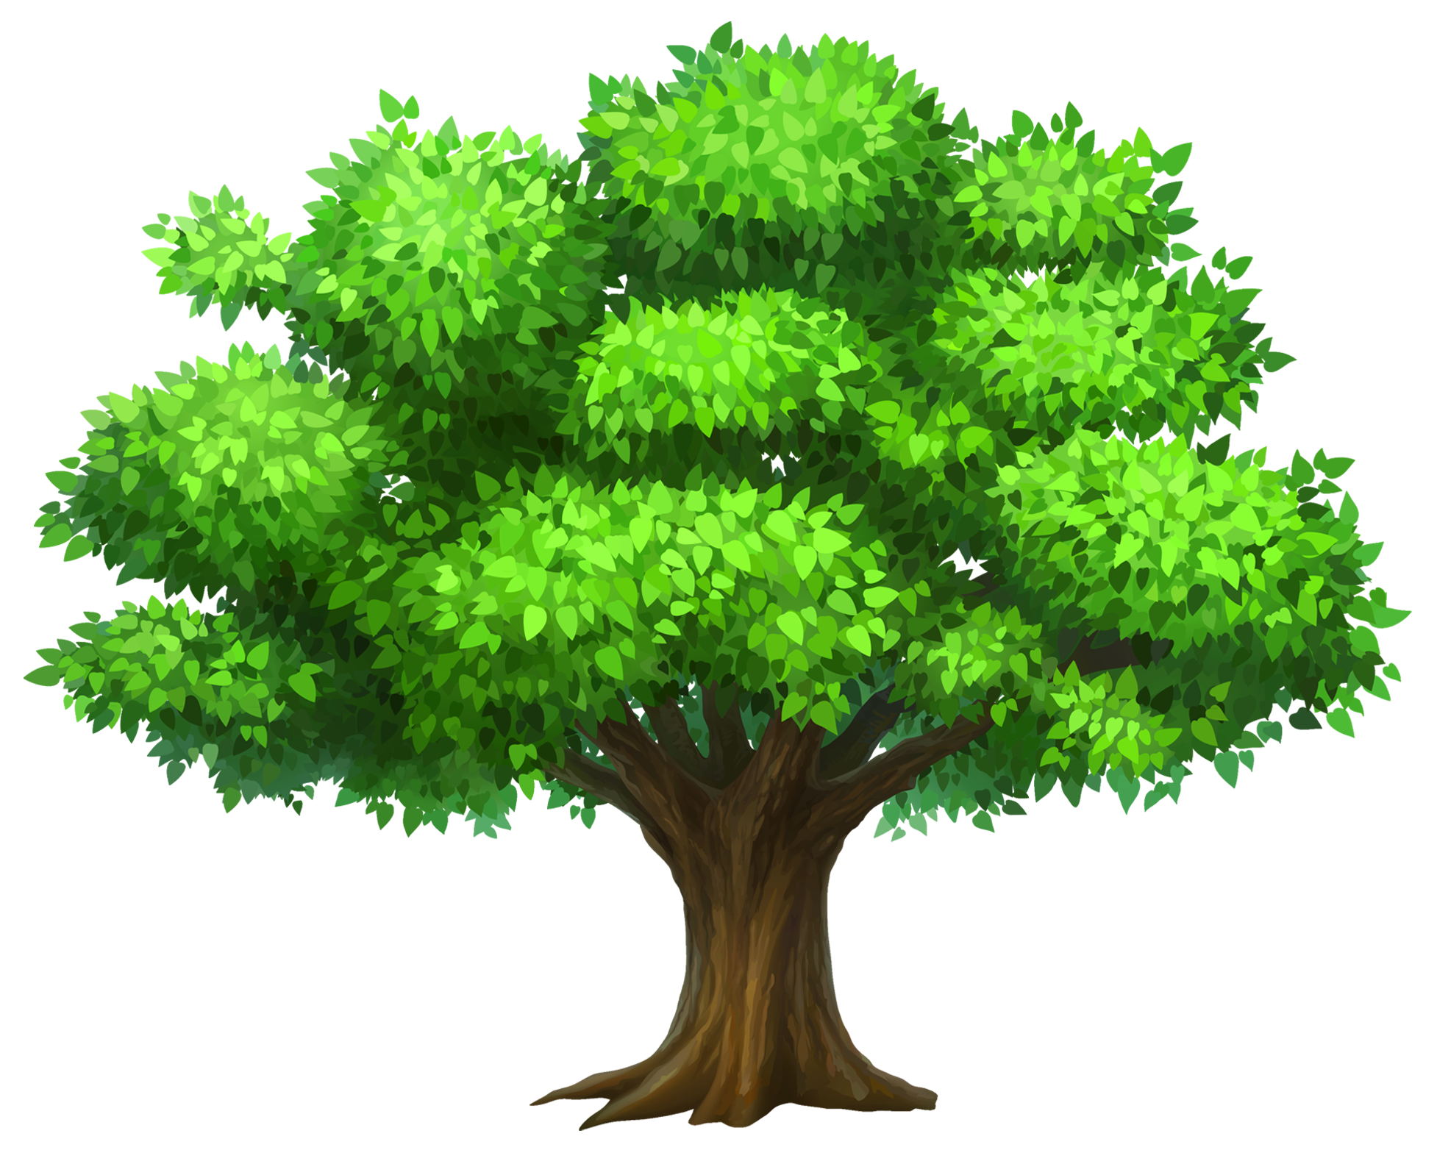

**MUSUBI MEETING**

Add 3/3/3 druid token for each of these tokens you have.

Discard a mana orb for each token you have

Discard a card from your reserve or a permanent for each token you have

Discard a creature from play for each of these tokens you have. If you can’t, instead add a 1/1/1 recruit and CHARGE.



12

12

12

NOON

Exceed each biome score in at least two biomes to complete the Musubi ceremony

**COMPANION**

**HERO**

A

A

**At Noon:** Discard a permanent. If you can’t discard a card from reserve.

**TUMULT EVENTS**

**Axiom**

**Bravos**

**Lyra**

**Muna**

**Ordis**

**Yzmir**

**At Noon:** Sacrifice a mana orb OR a permanent.

**At Noon:** Discard your reserve down to 1 card.

**At Noon:** Discard a non-token character from play.

**At Noon:** Discard your hand down to 2 cards

**At Noon:** Discard a permanent OR all tokens from play.

**SCENARIO DIFFICULTY**

**10**

Less Challenging

**12**

Standard

**15**

Challenging

**18**

Fiendish

Choose the difficulty you wish to play against at the start of the game. The default difficulty is 12.

**1**

**1**

**1**

**1**

**1**

**1**

**0**

**3**

**0**

**0**

**3**

**0**

**0**

**3**

**0**

**X**

**X**

**X**

**X**

**X**

**X**

**X**

**X**

**X**

**X**

**X**

**X**

**X**

**X**

**X**

**X**

**X**

**X**

**2**

**2**

**2**

**Anchored**

**2**

**2**

**2**

**Anchored**

**2**

**0**

**0**

**2**

**0**

**0**

**2**

**0**

**0**

**2**

**0**

**0**

**2**

**0**

**0**

**2**

**0**

**0**

**2**

**0**

**0**

**3**

**3**

**3**

**3**

**3**

**3**

**3**

**3**

**3**

**3**

**3**

**3**

**X**

**X**

**X**

**-1**

**-1**

**-1**

**-1**

**-1**

**-1**

**2**

**0**

**0**

**-1**

**-1**

**-1**

**-1**

**-1**

**-1**

**2**

**2**

**2**

**4**

**4**

**4**

Double Sided Tokens

**BIG LAKE TOKEN All Chars get 0/0/-2**

**RUNAWAY MACHINE Landmark Permanent**

**RUNAWAY MACHINE Landmark Permanent**